EMEFEI ______________________________________________
NOME:____________________________________________
PROFESSOR:______________________________ 1°ANO

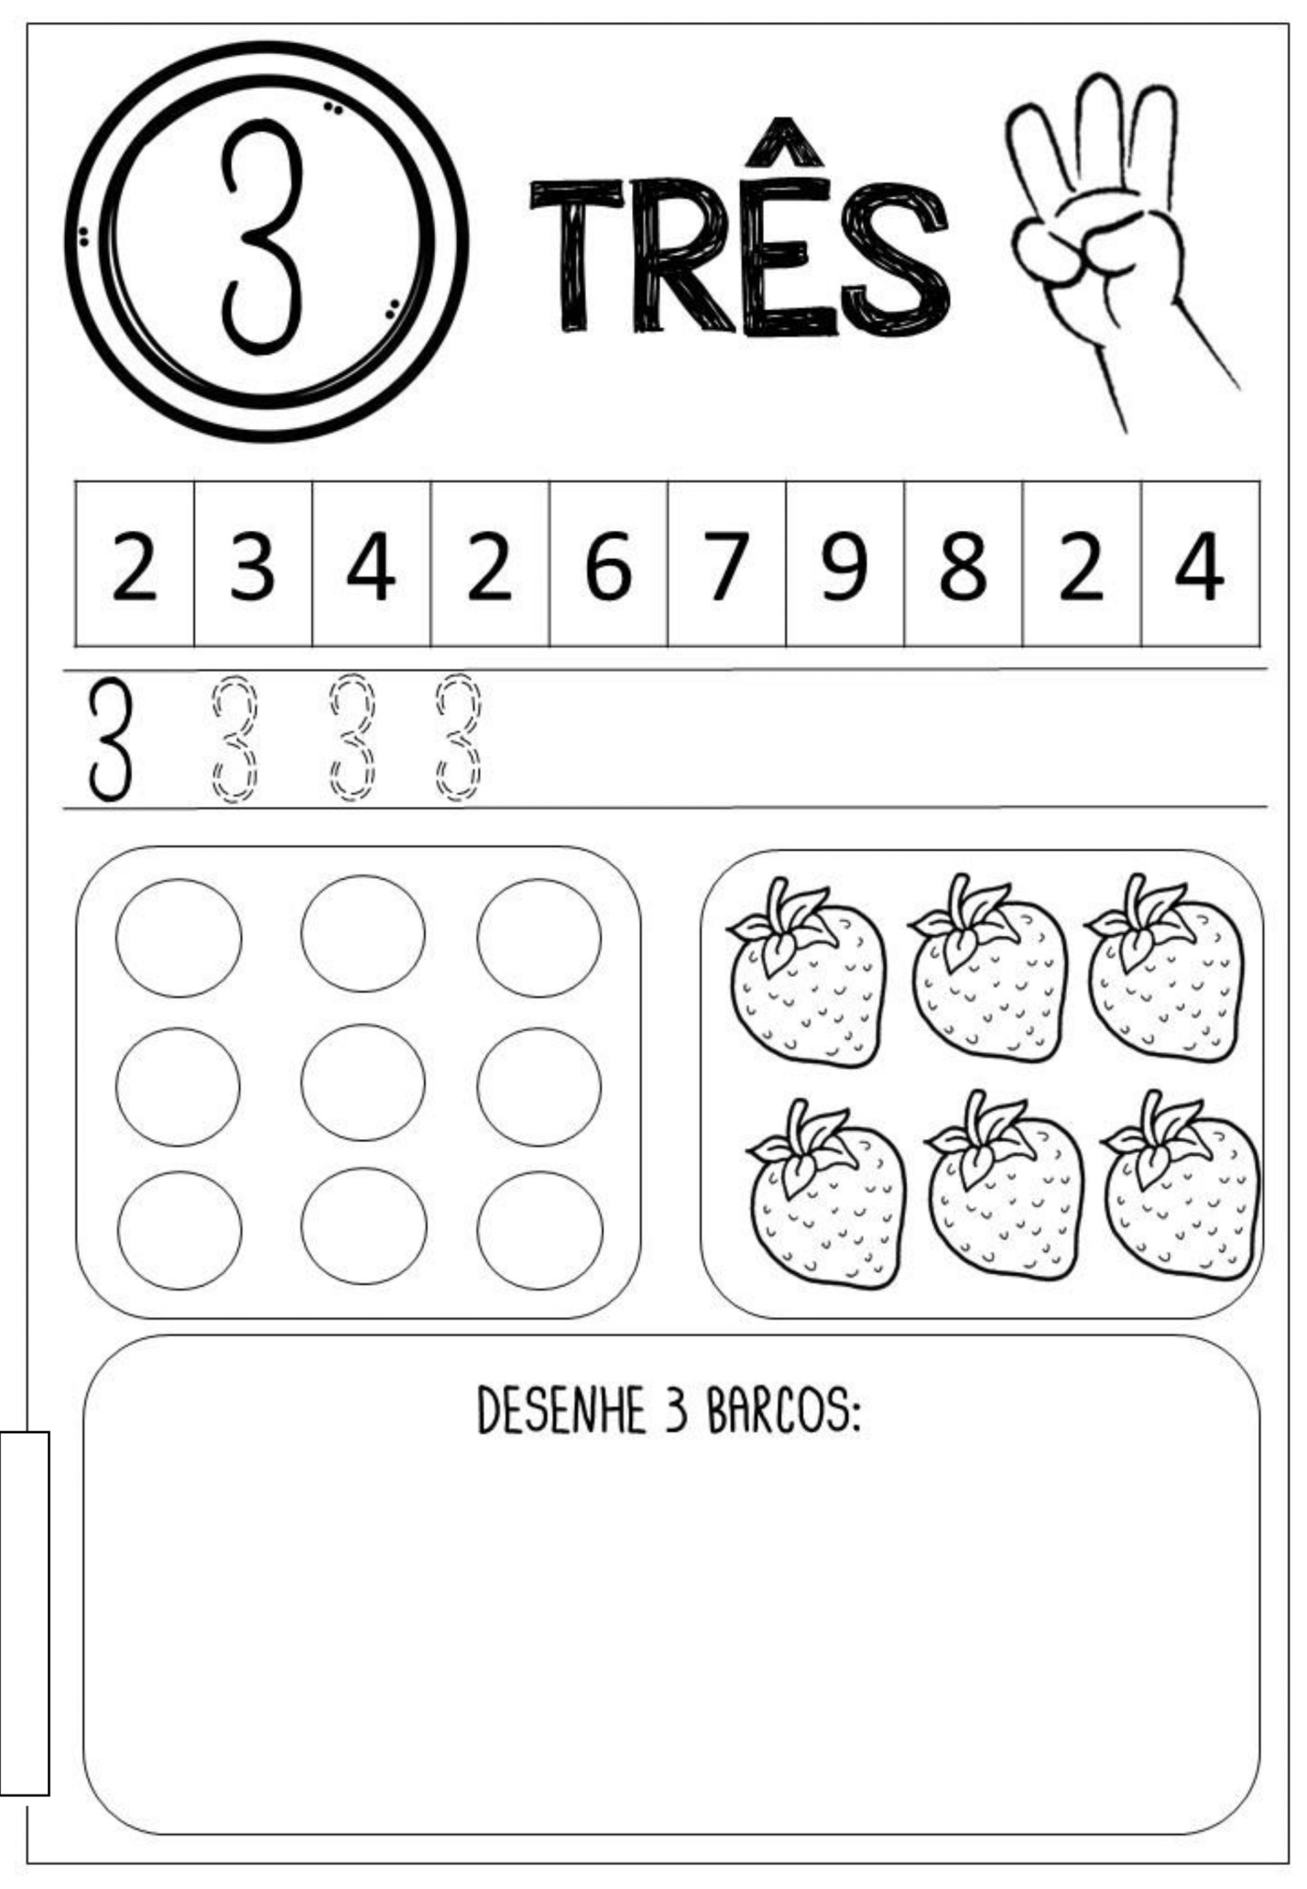

EMEFEI ______________________________________________
NOME:____________________________________________
PROFESSOR:________________________________ 1°ANO

